***SOFTWARE ENGINEERING***

LAB Manual

**Course Outcomes(CO’s)**

**CO1:** Develop the Problem Statement for the given system

**CO2:** Capture the Requirements Specification for an intended Software System Using DFD

**CO3:** Capture the requirements specification for an intended Software system Using use case Modeling

**CO4:** Draw the Structural and behavioral Diagrams for the given specification.

**CO5:** Draw the Sequence Diagram for the given specifications.

**CO6:** Develop Activity Diagram and State Chart Diagram for the Given Specifications.

**INDEX**

|  |  |  |  |  |
| --- | --- | --- | --- | --- |
| **S.No.** | **List of Experiments** | **Page.No.** | **Date** | **Remarks** |
| 1. | Online Course Reservation System |  |  |  |
| 2. | Railway Reservation System |
| 3. | Exam Registrations |
| 4. | Stock Maintenance Systems |
| 5. | Recruitment Systems |
| 6.  7.  8. | Library Management Systems Student Information Systems ATM |

# INSTITUTION VISION AND MISSION

**VISION**

To establish as an ideal academic institutions in the service of the nation, the world and the humanity by graduating talented engineers to be ethically strong, globally competent by conducting high quality research, developing breakthrough technologies, and disseminating and preserving technical knowledge.

# MISSION

To fulfill the promised vision through the following strategic characteristics and aspirations:

* Contemporary and rigorous educational experiences that develop the engineers and managers.
* An atmosphere that facilitates personal commitment to the educational success of students in an environment that values diversity and community.
* Undergraduate programs that integrate global awareness, communication skills and team building.
* Education and Training that prepares students for interdisciplinary engineering research and advanced problem solving abilities.

#### Prerequisites:

 A Course On “Database Management Systems” **Course Objectives:**

* + To Write the Problem Statement for the given System.
  + To Specify Software Requirement Using Data Flow Diagram.
  + To Draw Structural and Behavioral diagrams for the given Specifications.

#### Course Outcomes:

 Develop the Problem Statement for the given system

 Capture the Requirements Specification for an intended Software System Using DFD

 Capture the requirements specification for an intended Software system Using use case Modeling

Draw the Structural and behavioral Diagrams for the given specification. Draw the Sequence Diagram for the given specifications.



Develop Activity Diagram and State Chart Diagram for the Given Specifications.

#### Sample Domains:

1. Online Course Reservation System
2. Railway Reservation System
3. Exam Registrations 4. Stock Maintenance Systems
4. Recruitment Systems.
5. Library Management Systems.
6. Student Information Systems.
7. ATM

**Perform the following Experiments on Above Domains** 1. Identify the software system that need to be Developed.

1. Document the SRS for the identified System.
2. Draw the level 0, level 1, and level 2 DFD for the Identified System.
3. Draw the Class Diagrams and show Various Class Relationships.
4. Draw the UML Component and Deployment Diagram for the identified System.
5. Identify the use cases and Develop the Use case Model with include and external Relationships.
6. Using the identified Scenarios find interaction between objects and represent using Sequence diagram.
7. Using the identified Scenarios find interaction between objects and represent using Collaboration diagram.
8. Draw the relevant Activity Diagram for the Same System
9. Draw the relevant State Chart diagram for the same System

**WEEK:1**

# ONLINE COURSE RESERVATION SYSTEM

#### Problem Statement

The system is built to be used by students and managed by an administrator. The student and employee have to login to the system before any processing can be done. The student can see the courses available to him/her and register to the course he/she wants. The administrator can maintain the course details and view all the students who have registered to any course.

#### SRS Document

**1.0. INTRODUCTION**

**Course Reservation System** is an interface between the Student and the Registrar responsible for the issue of Course. It aims at improving the efficiency in the issue of Course and reduces the complexities involved in it to the maximum possible extent.

* 1. **PURPOSE**

If the entire process of 'Issue of Course' is done in a manual manner then it would takes several months for the course to reach the applicant. Considering the fact that the number of applicants for course is increasing every year, an Automated System becomes essential to meet the demand. So this system uses several programming and database techniques to elucidate the work involved in this process.

* 1. **SCOPE**
     + The System provides an online interface to the user where they can fill in their personal details and submit the necessary documents (may be by scanning).
     + The Registrar concerned with the issue of course can use this system to reduce his workload and process the application in a speedy manner.
     + Provide a communication platform between the Student and the Registrar.
  2. **DEFINITIONS, ACRONYMS AND THE ABBREVIATIONS**
     + **Registrar**

Refers to the super user with the privilege to manage the entire system.

* + - **Applicant**

One who wishes to register the Course

* + - **OCRS**

Refers to online Course Reservation System.

* + - **HTML**

Markup Language used for creating web pages.

* + - **J2EE**

Java 2 Enterprise Edition is a programming platform java platform for developing and running distributed java applications.

* + - **HTTP**

Hyper Text Transfer Protocol.

* + - **TCP/IP**

Transmission Control Protocol/Internet Protocol is the communication protocol used to connect hosts on the Internet.

* 1. **REFERENCES**

IEEE Software Requirement Specification format.

* 1. **TECHNOLOGIES TO BE USED**
* HTML
* JSP
* Javascript
* Java
  1. **TOOLS TO BE USED**
* Eclipse IDE (Integrated Development Environment)
* Rational Rose tool/ STAR UML(for developing UML Patterns)
  1. **OVERVIEW**

SRS includes two sections overall description and specific requirements

**Overall Description** will describe major role of the system components and inter- connections.

**Specific Requirements** will describe roles & functions of the actors.

* 1. **OVERALL DESCRIPTION**
  2. **PRODUCT PERSPECTIVE**

The OCRS acts as an interface between the 'Student' and the 'Registrar'. This system tries to make the interface as simple as possible and at the same time not risking the security of data stored in. This minimizes the time duration in which the user receives the course.

* 1. **SOFTWARE INTERFACE**
* **Front End Client** - The Student and Registrar online interface is built using JSP and HTML. The Administrators's local interface is built using Java.
* **Web Server** – Tomcat Apache application server (Oracle Corporation).
* **Back End** – Oracle 11g database.
  1. **HARDWARE INTERFACE**

The server is directly connected to the client systems. The client systems have access to the database in the server.

* 1. **SYSTEM FUNCTIONS**
* Secure Reservation of information by the Students.
* SMS and Mail updates to the students by the Registrar
* Registrar can generate reports from the information and is the only authorized personnel to add the eligible application information to the database.
  1. **USER CHARACTERISTICS**
     + **Applicant** - They are the person who desires to obtain the course and submit the information to the database.
     + **Administrator** - He has the certain privileges to add the course status and to approve the issue of course. He may contain a group of persons under him to verify the documents and give suggestion whether or not to approve the dispatch of course.
  2. **CONSTRAINTS**
     + The passengers require a computer to submit their information.
     + Although the security is given high importance, there is always a chance of intrusion in the web world which requires constant monitoring.
     + The user has to be careful while submitting the information. Much care is required.
  3. **ASSUMPTIONS AND DEPENDENCIES**
     + The Applicants and Administrator must have basic knowledge of computers and English Language.
     + The applicants may be required to scan the documents and send.

1. **Data Flow Diagrams**

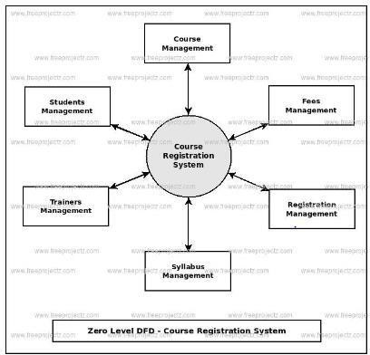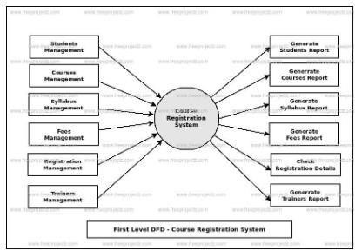

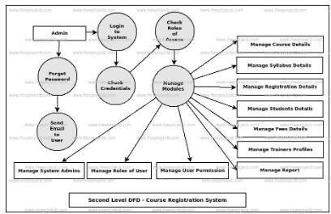

1. **CLASS DIAGRAM**

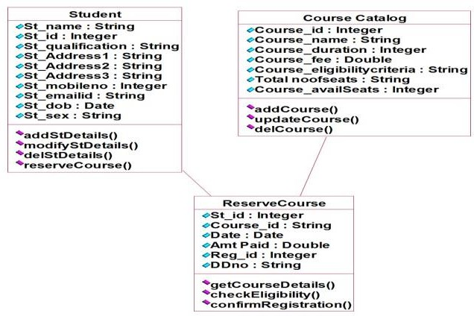

1. **COMPONENT AND DEPLOYMENT DIAGRAM**

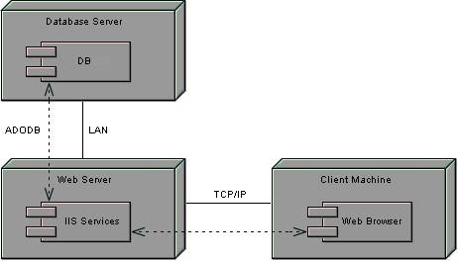

**Component Diagram**

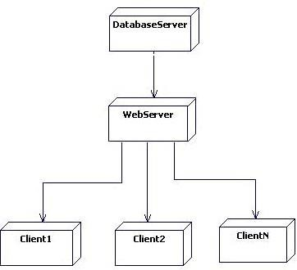

**Deployment Diagram**

1. **USE CASE DIAGRAM**

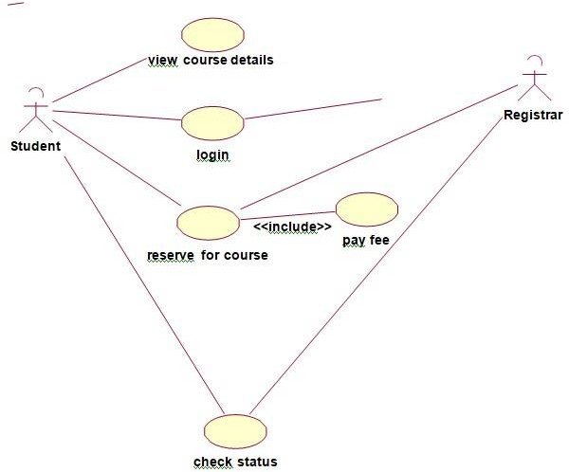

1. **SEQUENCE DIAGRAM**

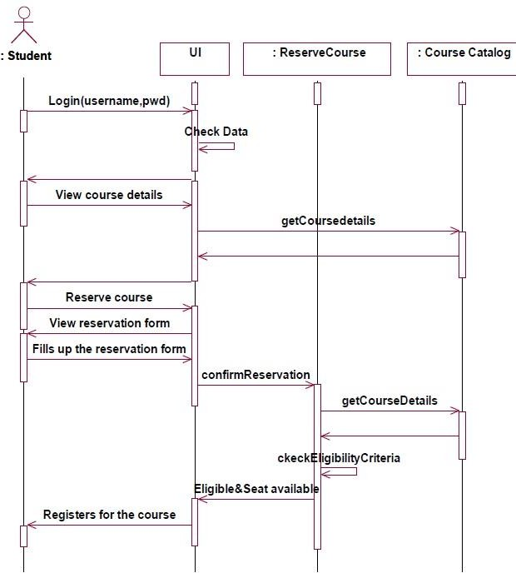

1. **COLLABORATION DIAGRAM**

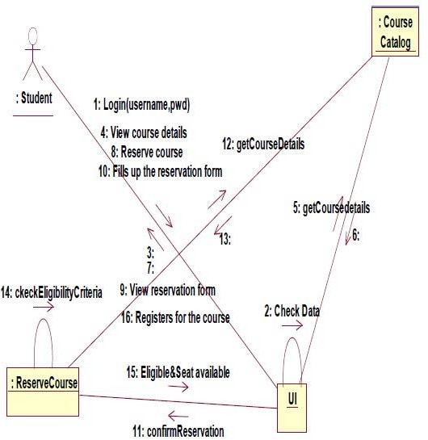

1. **ACTIVITY DIAGRAM**

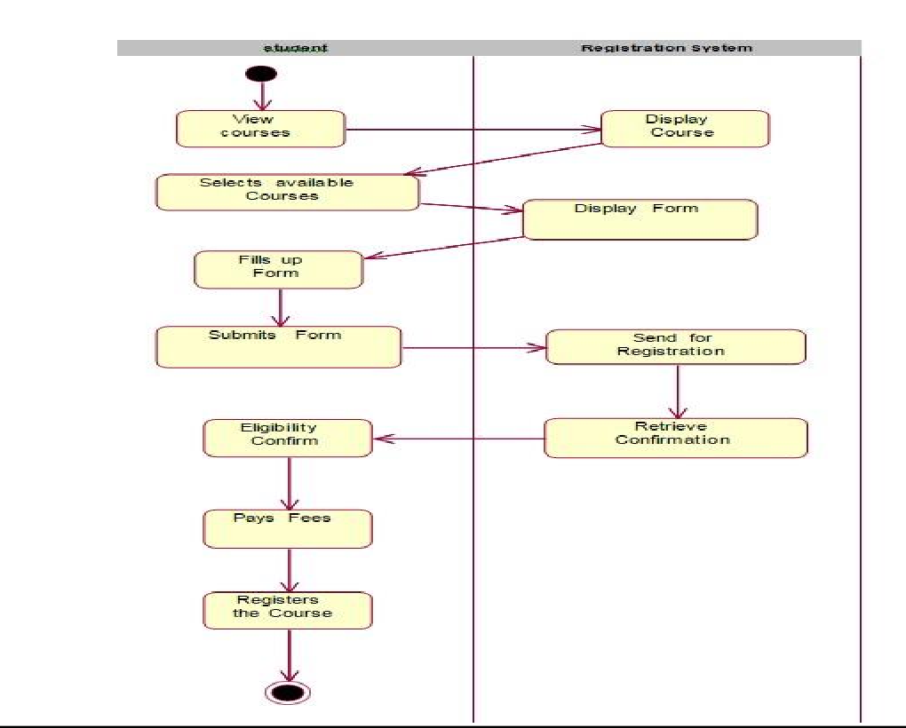

1. **STATE CHART DIAGRAM**

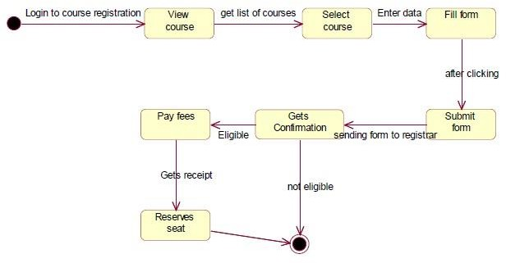

## Viva Questions And Answers

* 1. What is computer software?

Computer software is a complete package, which includes software program, its documentation and user guide on how to use the software.

* 1. What is software engineering?

Software engineering is an engineering branch associated with software system development.

* 1. What is software process or Software Development Life Cycle (SDLC)?

Software Development Life Cycle, or software process is the systematic development of software by following every stage in the development process namely, Requirement Gathering, System Analysis, Design, Coding, Testing, Maintenance and Documentation in that order.

* 1. What are SDLC models available?

There are several SDLC models available such as Waterfall Model, Iterative Model, Spiral model, Vmodel and Big-bang Model etc.

* 1. What are various phases of SDLC?

The generic phases of SDLC are: Requirement Gathering, System Analysis and Design, Coding, Testing and implementation. The phases depend upon the model we choose to develop software.

* 1. What is software project management?

Software project management is process of managing all activities like time, cost and quality management involved in software development.

* 1. Who is software project manager?

A software project manager is a person who undertakes the responsibility of carrying out the software project.

* 1. How can you measure project execution?

We can measure project execution by means of Activity Monitoring, Status Reports and Milestone Checklists.

* 1. What are software requirements?

Software requirements are functional description of proposed software system. Requirements are assumed to be the description of target system, its functionalities and features. Requirements convey the expectations of users from the system.

* 1. How can you gather requirements?

Requirements can be gathered from users via interviews, surveys, task analysis, brainstorming, domain analysis, prototyping, studying existing usable version of software, and by observation.

**WEEK:2**

# RAILWAY RESERVATION SYSTEM

#### Problem Statement

Our project is carried out to develop software for online Railway Reservation System. This system has various options like reservation, cancellation and to view details about available seats. Our project mainly simulates the role of a Railway ticket booking officer, in a computerized way.

The reservation option enables a person to reserve for a ticket at their home itself. All he/ she has to do is to just login and enter the required details. After this the reservation database is updated with the person details, train name and also the source and destination place.

The cancellation option enables the passenger to cancel the tickets that has been already booked by him/her. The availability option prompts the person to enter train number, train name and date of travel. After this the availability database is accessed and available positions are produced.

#### SRS Document

**1.0. INTRODUCTION**

The manual system of ticket reservation takes more time and the number of reservations per day is limited. To increase the efficiency of the process, we go for online ticket reservation system. This system supports online ticket booking.

* 1. **PURPOSE**

If the entire process of reservation is done in a manual manner then it would takes several months for reservation to reach the applicant. Considering the fact that the number of passenger is increasing every year, an Automated System becomes essential to meet the demand. So this system uses several programming and database techniques to elucidate the work involved in this process. As this is a matter of National Security, the system has been carefully verified and validated in order to satisfy it.

* 1. **SCOPE**
     + The System provides an online interface to the user where they can fill in the personal details and submit the necessary documents (may be by scanning).
     + The authority concerned with the issue of railway can use this system to reduce his workload and process the application in a speedy manner.
     + Provide a communication platform between the passenger and the administrator.
     + Passenger will come to know their status of application and the date in which they must subject themselves for manual document verification.
  2. **DEFINITIONS, ACRONYMS AND THE ABBREVIATIONS**
     + **Passenger** – The person that who wishes to obtain the railway ticket.
     + **PNR** – Passenger Name Records
     + **HTML** - Markup Language used for creating web pages.
     + **J2EE** – Java 2 Enterprise Edition is a programming platform java platform for developing and running distributed java applications.
     + **HTTP** - Hyper Text Transfer Protocol.
       - **TCP/IP** – Transmission Control Protocol/Internet Protocol is the communication protocol used to connect hosts on the Internet.
  3. **REFERENCES**

IEEE Software Requirement Specification format.

* 1. **TECHNOLOGIES TO BE USED**
     + HTML
     + JSP
     + Javascript
     + Java
  2. **TOOLS TO BE USED**
     + Eclipse IDE (Integrated Development Environment)
     + Rational Rose tool/ STAR UML(for developing UML Patterns)
  3. **OVERVIEW**

SRS includes two sections overall description and specific requirements

**Overall Description** will describe major role of the system components and inter- connections.

**Specific Requirements** will describe roles & functions of the actors.

* 1. **OVERALL DESCRIPTION**
  2. **PRODUCT PERSPECTIVE**

This system tries to make the interface as simple as possible and at the same time not risking the security of data stored in. This minimizes the time duration in which the user receives the ticket.

* 1. **SOFTWARE INTERFACE**
* **Front End Client** - The passenger and System online interface is built using JSP and HTML. The Administrators's local interface is built using Java.
* **Web Server** – Apache Tomcat Server (Oracle Corporation)
* **Back End** - Oracle 11g database
  1. **HARDWARE INTERFACE**

The server is directly connected to the client systems. The client systems have access to the database in the server.

* 1. **SYSTEM FUNCTIONS**
* Secure Registration of information by the Passengers.
* System can generate reports from the information and is the only authorized personnel to add the eligible application information to the database.
* Display the requested pages to the user.
* Update the database after every successful process.
  1. **USER CHARACTERISTICS**

**Passenger** - They are the people who desire to obtain the ticket and submit the information to the database.

* 1. **CONSTRAINTS**
* The passengers require a computer to submit their information.
* Although the security is given high importance, there is always a chance of intrusion in the web world which requires constant monitoring.
* The user has to be careful while submitting the information. Much care is required.
  1. **ASSUMPTIONS AND DEPENDENCIES**
     + The Applicants and Administrator must have basic knowledge of computers and English Language.
     + The applicants may be required to scan the documents and send.

1. **Data Flow Diagrams**

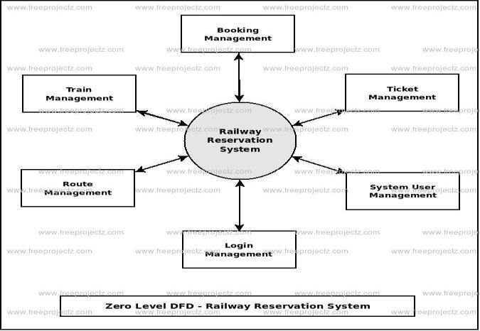

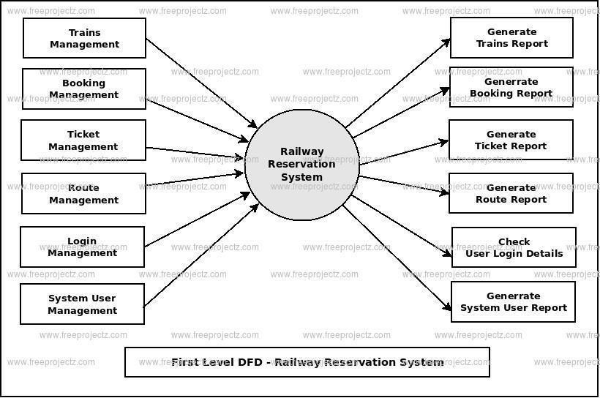

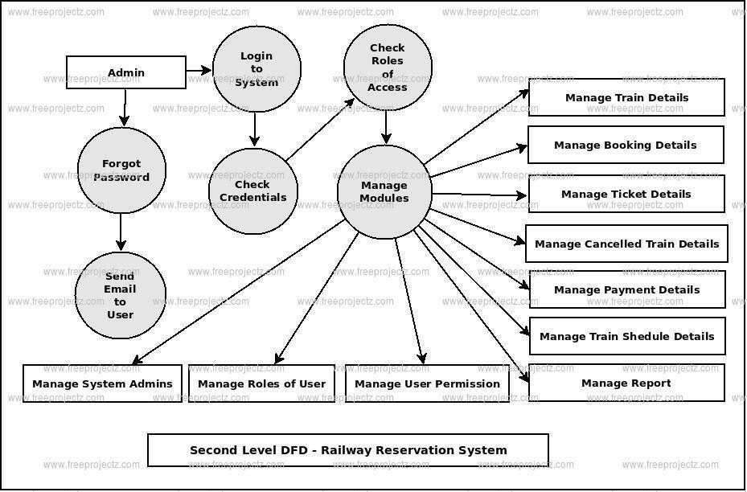

1. **CLASS DIAGRAM**

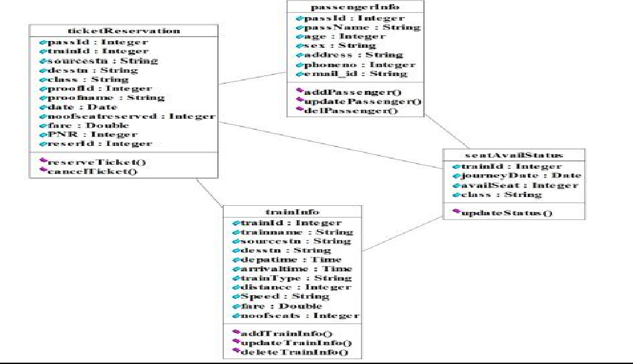

1. **COMPONENT AND DEPLOYMENT DIAGRAM**



**Component Diagram**



**Deployment Diagram**

1. **USE CASE DIAGRAM**

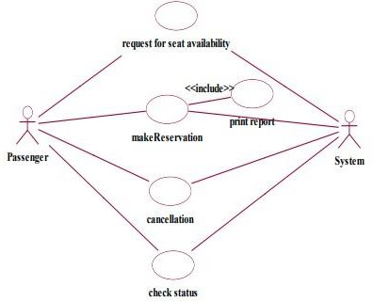

1. **SEQUENCE DIAGRAM**

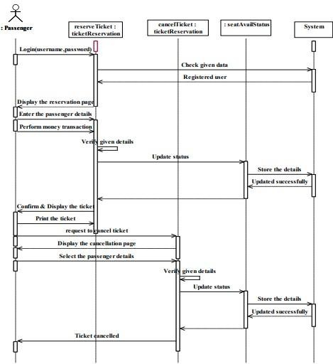

1. **COLLABORATION DIAGRAM**

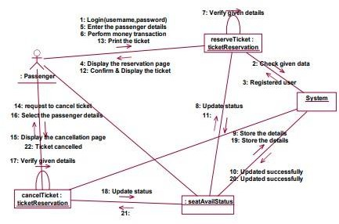

1. **ACTIVITY DIAGRAM**

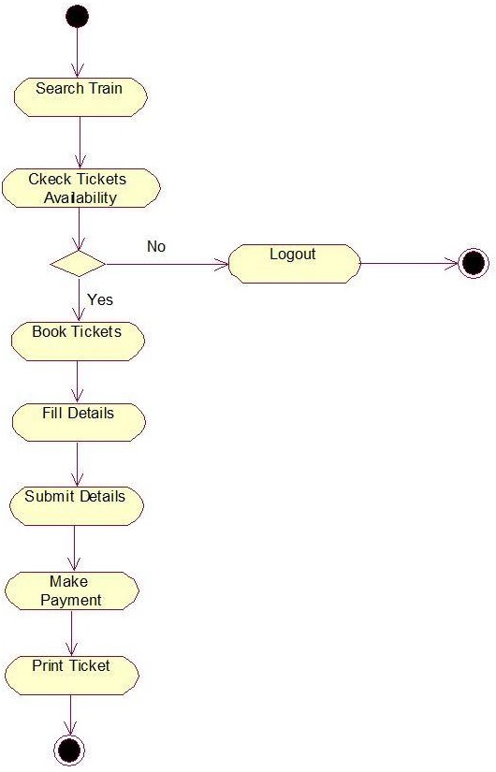

1. **STATE CHART DIAGRAM**

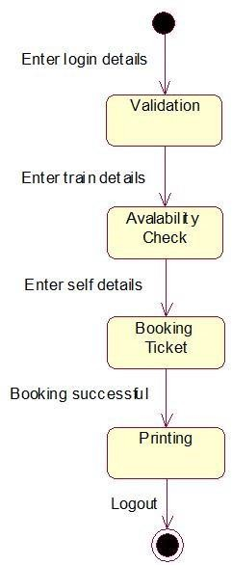

## Viva Questions And Answers

* 1. What is UML?

Ans: UML stands for the Unified Modeling Language.

It is a graphical language for 1) visualizing, 2) constructing, and 3) documenting the artifacts of a system. It allows you to create a blue print of all the aspects of the system, before actually physically implementing the system.

* 1. What are diagrams?

Ans: Diagrams are graphical representation of a set of elements most often shown made of things and associations.

* 1. What are the major three types of modeling used?

Ans: Major three types of modeling are structural, behavioral, and architectural.

* 1. Mention the different kinds of modeling diagrams used?

Ans: Modeling diagrams that are commonly used are, there are 9 of them. Use case diagram, Class Diagram, Object Diagram, Sequence Diagram, statechart Diagram, Collaboration Diagram, Activity Diagram, Component diagram, Deployment Diagram.

* 1. What is Architecture?

Ans: Architecture is not only taking care of the structural and behavioral aspect of a software system but also taking into account the software usage, functionality, performance, reuse, economic and technology constraints.

* 1. What is Static Diagrams?

Ans: Static Diagrams (Also called Structural Diagram): Class diagram, Object diagram, Component Diagram, Deployment diagram.

* 1. What is Dynamic Diagrams?

Ans: Dynamic Diagrams (Also called Behavioral Diagrams): Use Case Diagram, Sequence Diagram, Collaboration Diagram, Activity diagram, Statechart diagram.

* 1. What is an Use Case?

Ans: A use case specifies the behavior of a system or a part of a system, Use cases are used to capture the behavior that need to be developed. It involves the interaction of actors and the system.

* 1. What is modeling? What are the advantages of creating a model?

Ans: Modeling is a proven and well-accepted engineering technique which helps build a model. Model is a simplification of reality; it is a blueprint of the actual system that needs to be built. Model helps to visualize the system. Model helps to specify the structural and behavior of the system. Model helps make templates for constructing the system. Model helps document the system.

* 1. How are the diagrams divided?

Ans: The nine diagrams are divided into static diagrams and dynamic diagrams.

#### Problem Statement

**WEEK:3**

# EXAM REGISTRATION

Exam Registration system.is used in the effective dispatch of registration form to all of the students. This system adopts a comprehensive approach to minimize the manual work and schedule resources, time in a cogent manner. The core of the system is to get the online registration form (with details such as name, reg.no etc.,) filled by the student whose testament is verified for its genuineness by the Exam Registration System with respect to the already existing information in the database. This forms the first and foremost step in the processing of exam application. After the first round of verification done by the system, the information is in turn forwarded to the Exam Controller. The application is then processed manually based on the report given by the system. The system also provides the student

the list of exam dates.The controller will be provided with fees details to display the current status of application to the student, which they can view in their online interface. After all the necessary criteria has been met, the original information is added to the database and the hall ticket is sent to the student.

#### SRS Document

**1.0. INTRODUCTION**

Exam Registration System is an interface between the Student and the Exam Controller responsible for the Issue of Hall Ticket. It aims at improving the efficiency in the Issue of Hall ticket and reduces the complexities involved in it to the maximum possible extent.

* 1. **PURPOSE**

If the entire process of 'Issue of Hall ticket' is done in a manual manner then it would takes several days for the hall ticket to reach the student. Considering the fact that the number of students for hall ticket is increasing every year, an Automated System becomes essential to meet the demand. So this system uses several programming and database techniques to elucidate the work involved in this process. As this is a matter of National Security, the system has been carefully verified and validated in order to satisfy it.

* 1. **SCOPE**
     + The System provides an online interface to the user where they can fill in their personal details and submit the necessary documents (may be by scanning).
     + The controller concerned with the issue of hall ticket can use this system to reduce his workload and process the application in a speedy manner.
     + Provide a communication platform between the student and the controller.
     + Students will come to know their status of application and the date in which they must subject themselves for manual document verification.
  2. **DEFINITIONS, ACRONYMS AND THE ABBREVIATIONS**
     + **Exam Controller** - Refers to the super user who is the Central Authority who has been vested with the privilege to manage the entire system.
     + **Student** - One who wishes to obtain the Hall Ticket.
     + **ERS** - Refers to this Examination Registration System.
     + **HTML** - Markup Language used for creating web pages.
     + **J2EE** – Java 2 Enterprise Edition is a programming platform java platform for developing and running distributed java applications. • **HTTP** - Hyper Text Transfer Protocol.
     + **TCP/IP** – Transmission Control Protocol/Internet Protocol is the communication protocol used to connect hosts on the Internet.
  3. **REFERENCES**

IEEE Software Requirement Specification format.

* 1. **TECHNOLOGIES TO BE USED**
     + HTML
     + JSP
     + Javascript
     + Java
  2. **TOOLS TO BE USED**
     + Eclipse IDE (Integrated Development Environment)
     + Rational Rose tool/ STAR UML(for developing UML Patterns)
  3. **OVERVIEW**

SRS includes two sections overall description and specific requirements

**Overall Description** will describe major role of the system components and inter- connections.

**Specific Requirements** will describe roles & functions of the actors.

**2.0 OVERALL DESCRIPTION 2.1 PRODUCT PERSPECTIVE**

The ERS acts as an interface between the 'student' and the 'exam controller'. This system tries to make the interface as simple as possible and at the same time not risking the security of data stored in. This minimizes the time duration in which the user receives the hall ticket.

* 1. **SOFTWARE INTERFACE**
     + **Front End Client** -The exporter online interface is built using JSP and HTML
     + **Web Server** – Apache Tomcat Server (Oracle Corporation)
     + **Back End** - Oracle 11g database
  2. **HARDWARE INTERFACE**

The server is directly connected to the client systems. The client systems have access to the database in the server.

* 1. **SYSTEM FUNCTIONS**
     + Secure Registration of information by the Students.
     + SMS and Mail updates to the students by the controller.
     + Controller can generate reports from the information and is the only authorized personnel to add the eligible application information to the database.
  2. **USER CHARACTERISTICS**
     + **Student** - They are the people who desire to obtain the hall ticket and submit the information to the database.
     + **Exam controller** - He has the certain privileges to add the registration status and to approve the issue of hall ticket. He may contain a group of persons under him to verify the documents and give suggestion whether or not to approve the dispatch of hall ticket.
  3. **CONSTRAINTS**
     + The applicants require a computer to submit their information.
     + Although the security is given high importance, there is always a chance of intrusion in the web world which requires constant monitoring.
     + The user has to be careful while submitting the information. Much care is required.
  4. **ASSUMPTIONS AND DEPENDENCIES**
     + The Students and Exam Controller must have basic knowledge of computers and English Language.
     + The student may be required to scan the documents and send.

1. **Data Flow Diagrams**

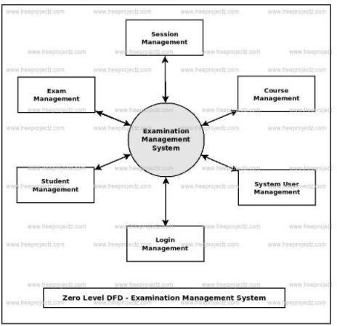

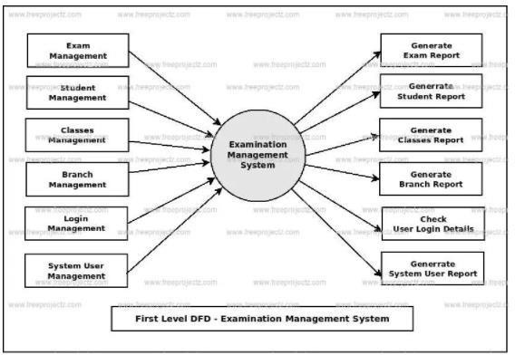

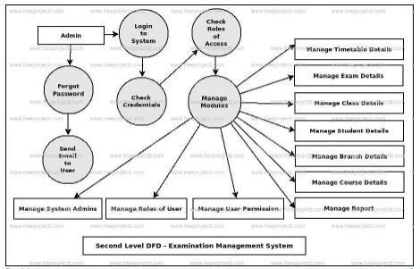

1. **CLASS DIAGRAM**

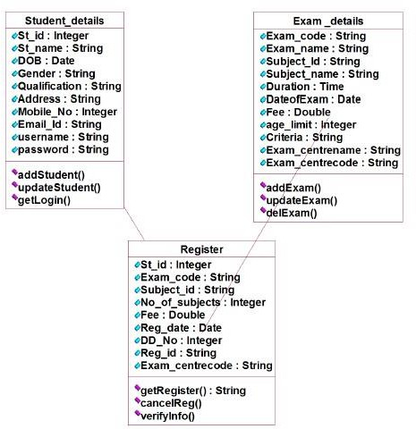

1. **COMPONENT AND DEPLOYMENT DIAGRAM**



**Component Diagram**



**Deployment Diagram**

1. **USE CASE DIAGRAM**

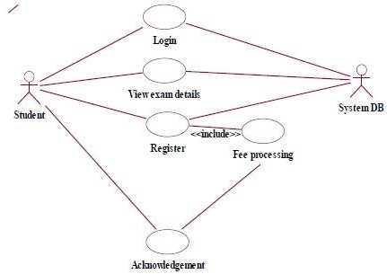

1. **SEQUENCE DIAGRAM**

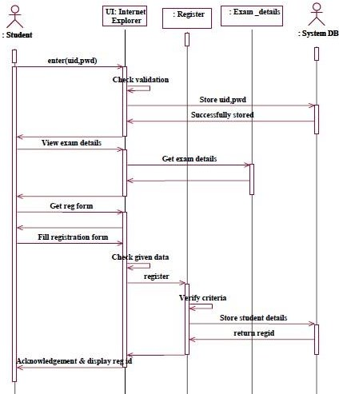

1. **COLLABORATION DIAGRAM**

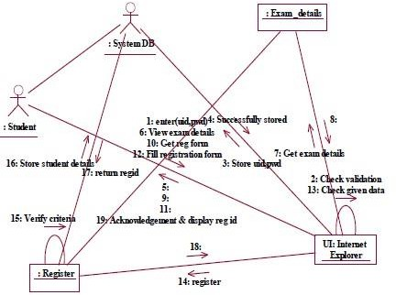

1. **ACTIVITY DIAGRAM**

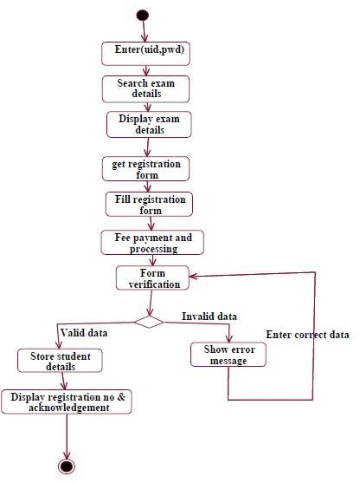

1. **STATE CHART DIAGRAM**

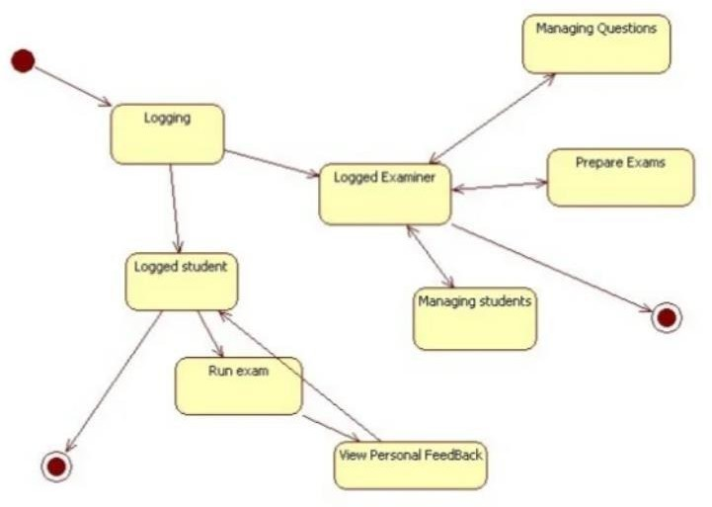

## Viva Questions And Answers

1. What is use case diagram?

Use case diagram is UML diagram which shows some business or software system, its external users (called [actors),](https://www.uml-diagrams.org/use-case-actor.html) and a set of actions (called [use cases)](https://www.uml-diagrams.org/use-case.html) that users of the system should or can perform while using the system. Use case diagrams are used to describe functionality of a system from the point of view of external users.

1. What is use case?

Each use case describes a unit of complete and useful functionality that business or system provides to its users, how external user interacts with a system to achieve a desired result. Some examples of use cases: Hire employee, Buy ticket, Place order, Deposit funds.

1. What is actor in use case diagrams?

Actor represents some group (called "role") of external customers or users of the business or software system. Actors have some needs and require specific services from the system. Some examples of actors are: Customer, Student, and Passenger. Actor could be not just human but also another system, business, or device.

1. What is the difference between use case diagram and use case?

Use case diagram shows business or system, its external users, and use cases applicable to the system. Use case represents one specific goal or need of the user from the system.

1. What are SDLC models available?

Waterfall Model, Spiral Model, Big-bag model, Iterative Model, and V- Model are some of the famous SDLC models.

1. What is verification and validation?

Verification is a term that refers to the set of activities which ensure that software implements a specific function. Validation refers to the set of activities which ensure that software that has been built according to the need of clients.

1. In software development process what is the meaning of debugging?

Debugging is the process that results in the removal of error. It is very important part of the successful testing.

1. How can you make sure that your code is both safe and fast?

In the software, development security is always first. So if the execution of the program is slow then, I will try to identify the reason out ways to its time complexity.

1. Name two tools which are used for keeping track of software requirements?

There many l ways to keep track of requirements. Two commonly used are:

* + Make a requirements specifications document to list all of the requirements.
  + Create an excel sheet the list down the requirement, type, dependency, priority, etc.

10). What language do you like to write programming algorithms?

Every developer has their views when it comes to the programming language choices. Though, one should prefer high-level languages because they are dynamic. Like C and C++ languages.

**WEEK:4**

# STOCK MAINTENANCE

#### Problem Statement

The stock maintenance system must take care of sales information of the company and must analyze the potential of the trade. It maintains the number of items that are added or removed. The sales person initiates this Use case. The sales person is allowed to update information and view the database.

#### SRS Document

**1.0. INTRODUCTION**

Stock maintenance is an interface between the customer and the sales person. It aims at improving the efficiency in maintaining the stocks.

* 1. **PURPOSE**

If the entire process of 'Issue of Hall ticket' is done in a manual manner then it would takes several days for the hall ticket to reach the student. Considering the fact that the number of students for hall ticket is increasing every year, an Automated System becomes essential to meet the demand. So this system uses several programming and database techniques to elucidate the work involved in this process. As this is a matter of National Security, the system has been carefully verified and validated in order to satisfy it.

* 1. **SCOPE**
     + The System provides an interface to the customer where they can fill in orders for the item needed.
     + The sales person is concerned with the issue of items and can use this system.
     + Provide a communication platform between the customer and the sales person.
  2. **DEFINITIONS, ACRONYMS AND THE ABBREVIATIONS**
     + **Market Data provider**: One who analyze the product and distribute the news.
     + **Customer:** One who takes order of product
     + **Sales person:** One who maintains the stock details
  3. **REFERENCES**

IEEE Software Requirement Specification format.

* 1. **TECHNOLOGIES TO BE USED**
* Visual Studio
* VB Script
  1. **TOOLS TO BE USED**
     + Eclipse IDE (Integrated Development Environment)
     + Rational Rose tool/ STAR UML(for developing UML Patterns)
  2. **OVERVIEW**

SRS includes two sections overall description and specific requirements

**Overall Description** will describe major role of the system components and inter- connections.

**Specific Requirements** will describe roles & functions of the actors.

* 1. **OVERALL DESCRIPTION**
  2. **PRODUCT PERSPECTIVE**

The Stock maintenance acts as an interface between the 'customer' and the 'sales person'. This system tries to make the interface as simple as possible and at the same time not risking the work of data stored in

* 1. **SYSTEM FUNCTIONS**
* Secure order of information by the custome.
* Schedule the customer an appointment for manual delivery of the product.
  1. **USER CHARACTERISTICS**

**Customer:** The person who orders for the item.

**Validate customer:** The items ordered by the customer are validated.

**Sales Detail:** Maintains the stock details after delivering the items to the customer.

* 1. **CONSTRAINTS**
* The customer should wait until the trade contractor and other to analyze the product.
* After the distribution of the news about the product. The customer can take order and request of sales person to fill it.
* Finally the sales person delivers the order.

1. **Data Flow Diagrams**

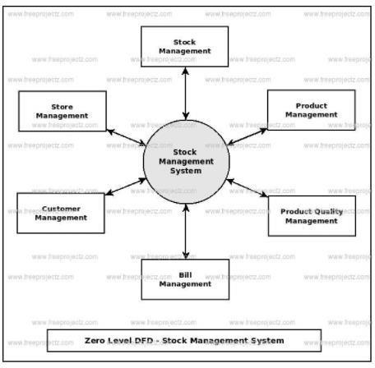

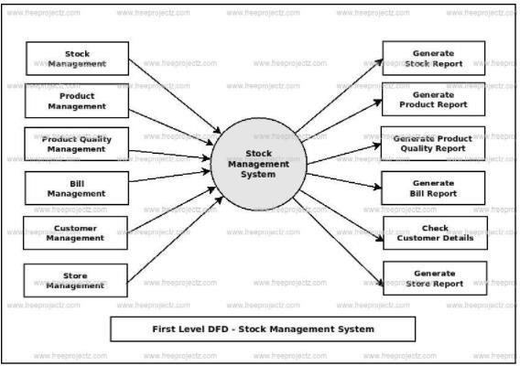

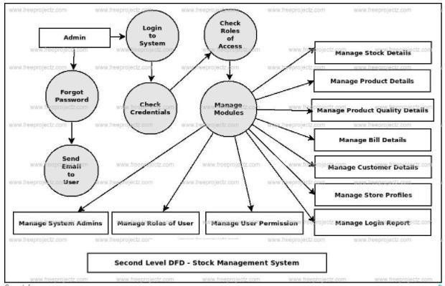

1. 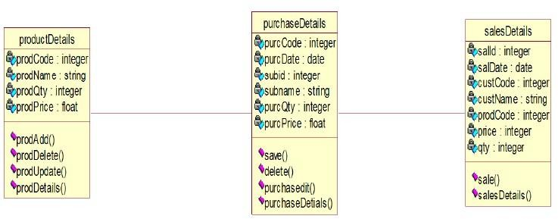**CLASS DIAGRAM**
2. **COMPONENT AND DEPLOYMENT DIAGRAM**



**Component Diagram**



**Deployment Diagram**

1. **USE CASE DIAGRAM**

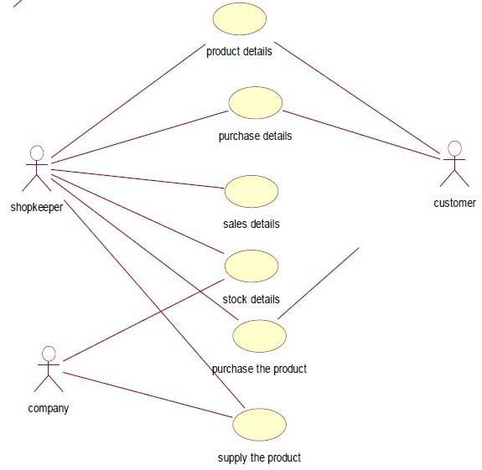

1. **SEQUENCE DIAGRAM**

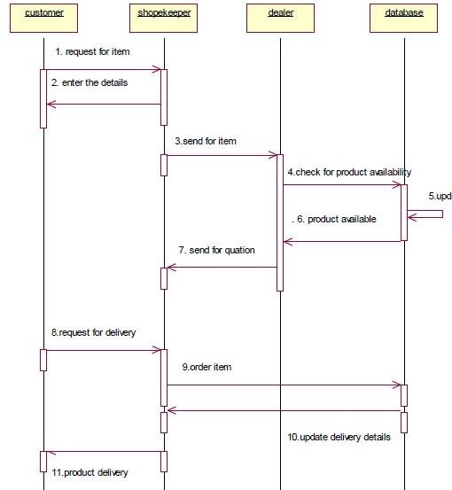

1. **COLLABORATION DIAGRAM**

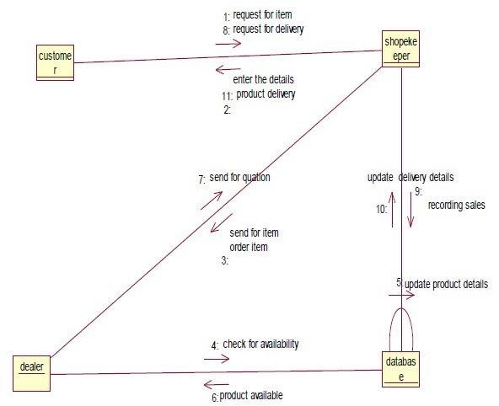

1. **ACTIVITY DIAGRAM**

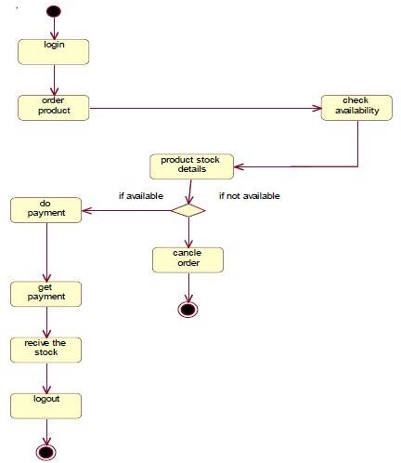

1. **STATE CHART DIAGRAM**

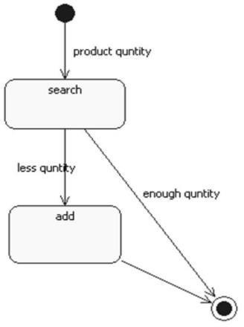

## Viva Questions And Answers

* 1. What is computer software?

Computer software is a package which includes a software program, its documentation, and user guide on how to use the software.

* 1. How can you measure project execution?

We can measure project execution using Activity Monitoring, Status Reports, and Milestone Checklists.

* 1. What are software requirements?

Software requirements are a functional description of a proposed software system. It is assumed to be the description of the target system, its functionalities, and features.

* 1. What is feasibility study?

It is a measure to find out how practical and beneficial the software project development will prove to the organization. The software analyzer conducts a study to know the economic, technical and operational feasibility of the project.

* 1. *What is a class?*

Ans: A class is a set of objects that share a common structure and a common behavior

* 1. *What is the need of a Class diagram*?

A class diagram is used to show the existence of classes and their relationships in the logical view of a system.

* 1. What is Class Diagram?

Class diagram describes the attributes and operations of a class and also the constraints imposed on the system.

* 1. Why we are using data Flow diagrams in software engineering?

It helps us to understand the functioning and the limits of a system. It is a graphical representation which is very easy to understand as it helps visualize contents. Data Flow Diagram represent detailed and well explained diagram of system components.

* 1. What is the Difference between Level 0 and Level 1 Data flow Diagrams?

Level 0 data flow diagrams show a single process node and its connections to external entities.

Level 1 DFDs are still a general overview, but they go into more detail than a level 0 data flow diagram.

* 1. Define component Diagram?

a component diagram depicts how components are wired together to form larger components or software systems. They are used to illustrate the structure of arbitrarily complex systems..

#### Problem Statement

**WEEK:5**

# RECRUITMENT SYSTEM

The recruitment system allows the job seekers to view the job opportunity through Advertisement and helps to apply for the job. The organization shortlist the applicants for the interview. The shortlisted applicants undergo through a process of Test and Interview. The HR department selects the Applicant based on the performance in the Test and Interview. Finally the recruited applicants are informed. This system makes the task of the job seeker easier rather than waiting in queue for enrollment. This also reduces the time consumption for both for the job seeker and organization.

#### SRS Document

**1.0. INTRODUCTION**

Recruitment System is an interface between the Applicant and the Organization responsible for the Recruitment. It aims at improving the efficiency in the Recruitment process and reduces the complexities involved in it to the maximum possible extent.

* 1. **PURPOSE**

If the entire process of ‘Recruitment' is done in a manual manner then it would takes several days for the recruitment. Considering the fact that the number of applicants for recruitment is increasing every year, an Automated System becomes essential to meet the demand. So this system uses several programming and database techniques to elucidate the work involved in this process.

* 1. **SCOPE**
     + The System provides an online interface to the user where they can fill in their personal details and apply for the job.
     + The Organization (HR-Department) concerned with the recruitment process can make use of this system to reduce their workload and process the application in a speedy manner.
     + Provide a communication platform between the Applicant and the Organization.
  2. **DEFINITIONS, ACRONYMS AND THE ABBREVIATIONS**

### Organization

Refers to the super user who is the Central Authority with the privilege to manage the entire system. It can be any higher official in the HR department.

### Applicant

One who wishes to apply for the job.

### RS

Refers to this Recruitment System.

### HTML

Markup Language used for creating web pages.

### J2EE

Java 2 Enterprise Edition is a programming platform java platform for developing and Running distributed java applications.

### HTTP

Hyper Text Transfer Protocol.

### TCP/IP

Transmission Control Protocol/Internet Protocol is the communication protocol used to connect hosts on the Internet.

* 1. **REFERENCES**

IEEE Software Requirement Specification format.

* 1. **TECHNOLOGIES TO BE USED**
     + HTML
     + JSP
     + Javascript
     + Java
  2. **TOOLS TO BE USED**
     + Eclipse IDE (Integrated Development Environment)
     + Rational Rose tool/ STAR UML(for developing UML Patterns)
  3. **OVERVIEW**

SRS includes two sections overall description and specific requirements

**Overall Description** will describe major role of the system components and inter- connections.

**Specific Requirements** will describe roles & functions of the actors.

* 1. **OVERALL DESCRIPTION**
  2. **PRODUCT PERSPECTIVE**

The RS acts as an interface between the ''Applicant and the 'Organization'. This system tries to make the interface as simple as possible and at the same time not risking the security of data stored in. This minimizes the time duration for recruitment process.

### SOFTWARE INTERFACE

* + - **Front End Client** –The Applicants and Organization online interface is built using JSP and HTML. The Administrators’ local interface is built using Java.
    - **Web Server** - Glassfish application server (SQL Corporation).
    - **Back End** - SQL database.

### HARDWARE INTERFACE

The server is directly connected to the client systems. The client systems have access to the database in the server.

* 1. **SYSTEM FUNCTIONS**
     + The applicant views the jobs through Advertisement.
     + Applicants apply for the job.
     + Test and Interview are conducted.
     + Recruited Applicants are informed.
     + HR Manager can generate reports from the information and he/she is the only authorized personnel to add the eligible application information to the database.
  2. **USER CHARACTERISTICS** ▪ **Applicant**

These are the persons who desire to apply for the job.

### Organization

These are the person with certain privileges to announce recruitment depending upon the organization need. He/ She may contain a group of persons under him/her to publish advertisement and give suggestion whether or not to approve the recruitment.

### HR

He/ She is the person who upon receiving intimation from the RS, perform a personal verification of the applicants and see if he/she has eligibility for the advertised job through a process of Test and Interview.

* 1. **CONSTRAINTS**
* The Applicants require a computer to submit their information.

### ASSUMPTIONS AND DEPENDENCIES

* The Applicants and HR must have basic knowledge of computers and English Language.

1. **Data Flow Diagrams**

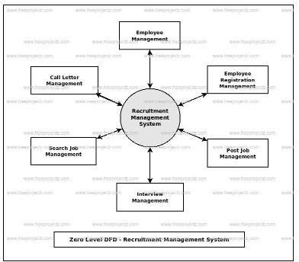

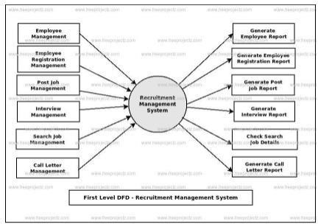

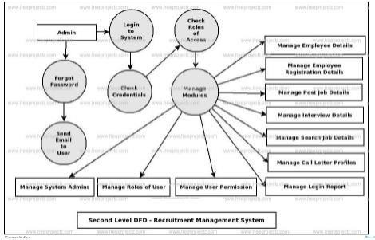

1. **CLASS DIAGRAM**

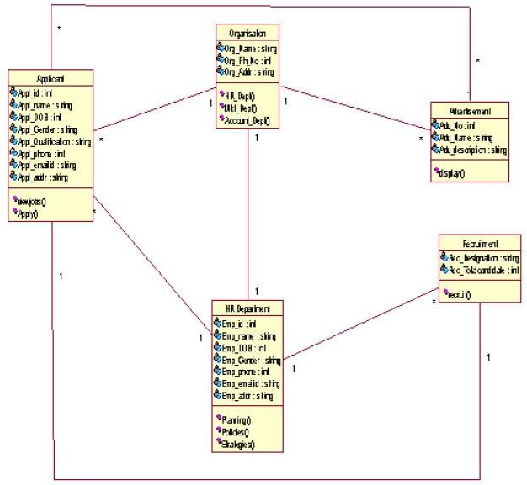

1. **COMPONENT AND DEPLOYMENT DIAGRAM**



**Component Diagram**



**Deployment Diagram**

1. **USE CASE DIAGRAM**

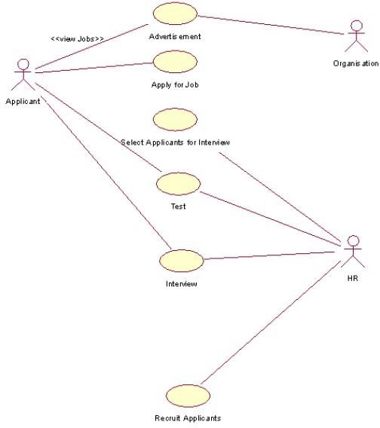

1. **SEQUENCE DIAGRAM**

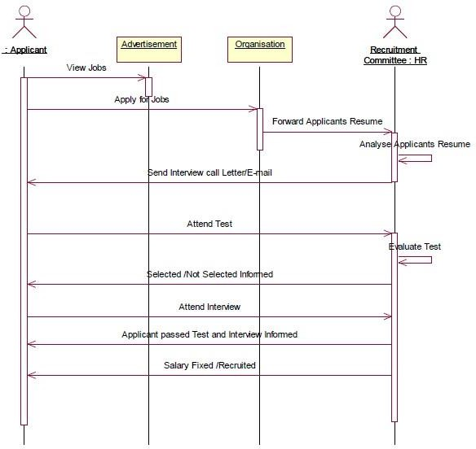

1. **COLLABORATION DIAGRAM**

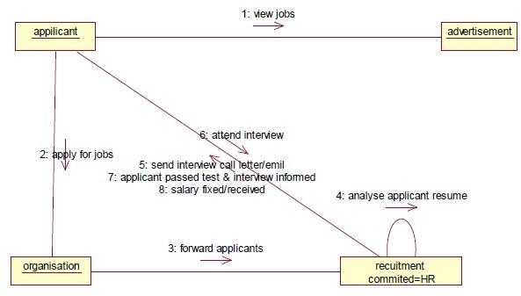

1. **ACTIVITY DIAGRAM**

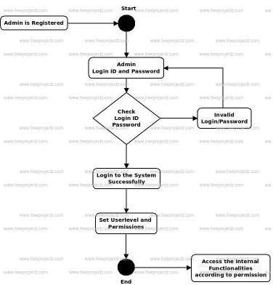

1. **STATE CHART DIAGRAM**

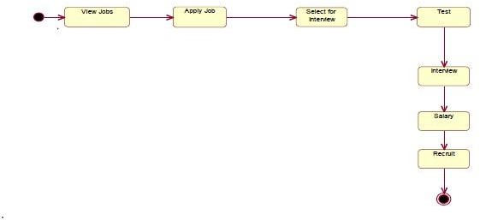

## Viva Questions And Answers

1) Define what is meant by a component.*?*

A physical element of a system, usually a file of some sort. can be a source file, used in producing the software for the system, or an element of the runtime system 2) Define what is meant by a node.

Processor in the implementation of a system, shown in a deployment diagram.

1. What is a notation for a component?



1. What is a notation for a node?



1. What are the main purposes of using component diagrams?

Model physical software components and the relationships between them;

Model source code and relationships between files; Model the structure of releases of software;

Specify the files that are compiled into an executable.

1. What are the main purposes of using deployment diagrams?

Model physical hardware elements and the communication paths between them; Plan the architecture of the system;

Document the deployment of software components on hardware nodes.

1. What is the difference between components in a component diagram and components in a deployment diagram?

Components shown in a deployment diagram model the deployment of run-time components on processors in the planned system. They are normally instances of components. Components in a component diagram are usually source files or other elements of the system software under development.

1. How are dependencies shown in a component diagram? As a dashed arrow with an open arrow head.
2. What is an Activity Diagram?

Activity diagram is basically a flowchart to represent the flow from one activity to another activity. The activity can be described as an operation of the system.

1. What is the purpose of activity Diagrams?

Ans: Activity diagrams are used to Capture the Dynamic behavior of the system.

#### Problem Statement

**WEEK:6**

# LIBRARY MANAGEMENT SYSTEM

The library management system is a software system that issues books and magazines to registered students only. The student has to login after getting registered to the system. The borrower of the book can perform various functions such as searching for desired book, get the issued book and return the book.

#### SRS Document

**1.0. INTRODUCTION**

With the increase in the number of readers, better management of libraries system is required. The Library management system focuses on improving the management of libraries in a city or town. “What If you can check whether a book is available in the library through your phone?” or “what if instead of having different library cards for different libraries you can just have one ?” or “you can reserve a book or issue a book from your phone sitting at your home!”. The Integrated Library Management system provides you the ease of issuing, renewing, or reserving a book from an library within your town through your phone. The Integrated Library Management system is developed on the android platform which basically focuses on issuing, renewing and reserving a book.

* 1. **PURPOSE**

The purpose of the project is to maintain the details of books and library members of different libraries. The main purpose of this project is to maintain a easy circulation system between clients and the libraries, to issue books using single library card, also to search and reserve any book from different available libraries and to maintain details about the user (fine, address, phone number).Moreover, the user can check all these features from their home.

* 1. **SCOPE**
     + Manually updating the library system into an android based application so that the user can know the details of the books available and maximum limit on borrowing from their computer and also through their phones.
     + The ILM System provides information's like details of the books, insertion of new books, deletion of lost books, limitation on issuing books, fine on keeping a book more than one month from the issued date.
     + Also user can provide feedback for adding some new books to the library.
  2. **DEFINITIONS, ACRONYMS AND THE ABBREVIATIONS**
* JAVA -> platform independence
* SQL -> Structured query Language ➢ DFD -> Data Flow Diagram ➢ CFD -> Context Flow Diagram.
* ER -> Entity Relationship
* IDE -> Integrated Development Environment
* SRS -> Software Requirement Specification
  1. **REFERENCES**

IEEE Software Requirement Specification format.

* 1. **TECHNOLOGIES TO BE USED**
     + HTML
     + JSP
     + Javascript
     + Java
  2. **TOOLS TO BE USED**
     + Eclipse IDE (Integrated Development Environment)
     + Rational Rose tool/ STAR UML(for developing UML Patterns)
  3. **OVERVIEW**

SRS includes two sections overall description and specific requirements

**Overall Description** will describe major role of the system components and inter- connections.

**Specific Requirements** will describe roles & functions of the actors.

* 1. **OVERALL DESCRIPTION**
  2. **PRODUCT PERSPECTIVE**

The proposed Library Management System will take care of the current book detail at any point of time. The book issue, book return will update the current book details automatically so that user will get the update current book details.

### SOFTWARE INTERFACE

* + - **Front End Client** –Android Developer Tool ,Adavance Java •

**Back End** - SQL database.

### HARDWARE INTERFACE

The server is directly connected to the client systems. The client systems have access to the database in the server.

* 1. **USER CHARACTERISTICS**

We have 3 levels of users :

* **User module**: In the user module, user will check the availability of the books.  Issue book

 Reserve book

Return book  Fine details

*  **Library module**: Add new book Remove books

Update details of book

* **Administration module:**

The following are the sub module in the administration module : Register  user

Entry book details Book issue



* 1. **CONSTRAINTS**
* The Applicants require a computer to submit their information.

### ASSUMPTIONS AND DEPENDENCIES

* The Applicants and HR must have basic knowledge of computers and English Language.

1. **Data Flow Diagrams**

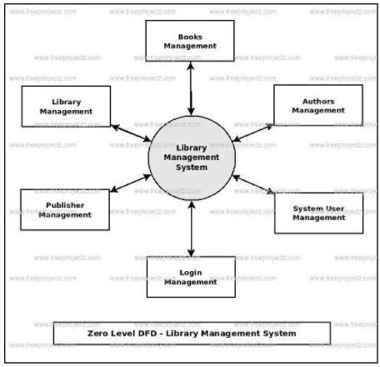

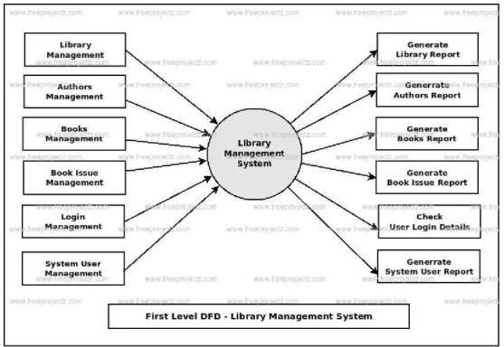

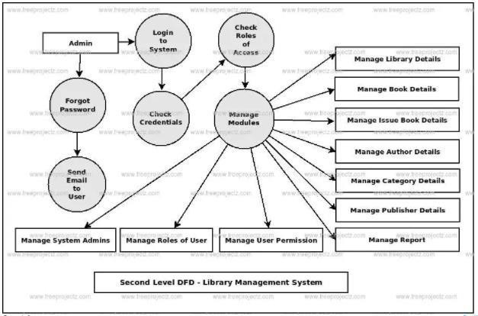

1. **CLASS DIAGRAM**

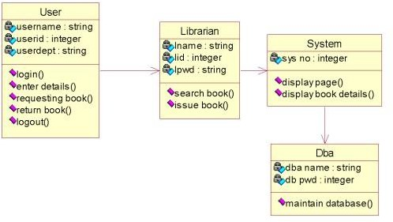

1. **COMPONENT AND DEPLOYMENT DIAGRAM**

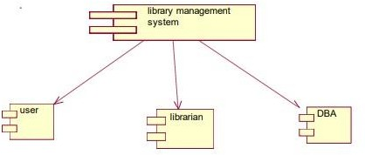

**Component Diagram**



**Deployment Diagram**

1. **USE CASE DIAGRAM**

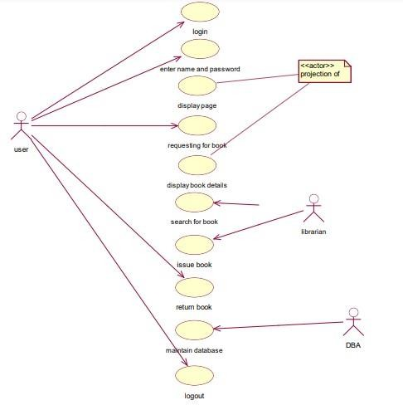

1. **SEQUENCE DIAGRAM**

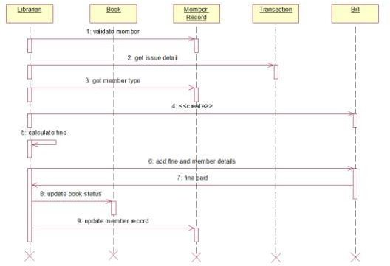

1. **COLLABORATION DIAGRAM**

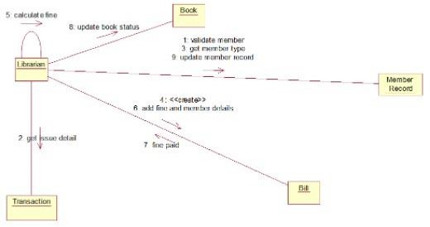

1. **ACTIVITY DIAGRAM**

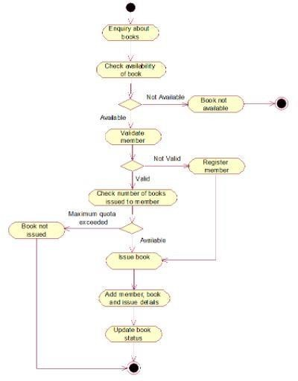

1. **STATE CHART DIAGRAM**

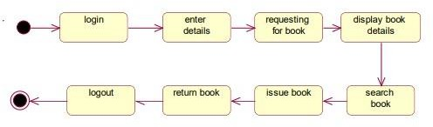

## Viva Questions And Answers

* 1. How to Draw an Activity Diagram

Before drawing an activity diagram, we must have a clear understanding about the elements used in activity diagram. The main element of an activity diagram is the activity itself. An activity is a function performed by the system. After identifying the activities, we need to understand how they are associated with constraints and conditions..

* 1. [What is a Sequence Diagram?](https://creately.com/blog/diagrams/sequence-diagram-tutorial/#WhatIs)

Sequence diagrams, commonly used by developers, model the interactions between objects in a single use case.

* 1. Draw Life Line Notation Which is used in sequence Diagram?

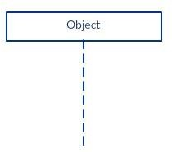

* 1. Why the Actor Element is used in Sequence Diagram?

A lifeline notation with an actor element symbol is used when the particular sequence diagram is owned by a use case

* 1. Why activation Bars are used in sequence Diagram?

Activation bar is the box placed on the lifeline. It is used to indicate that an object is active (or instantiated) during an interaction between two objects. The length of the rectangle indicates the duration of the objects staying active.

* 1. Write about Message arrows which are used in sequence Diagram?

An arrow from the Message Caller to the Message Receiver specifies a message in a sequence diagram. A message can flow in any direction; from left to right, right to left or back to the Message Caller itself.

* 1. Draw Notation to represent Synchronous message.



* 1. Write About Asynchronous message.

An asynchronous message is used when the message caller does not wait for the receiver to process the message and return before sending other messages to other objects within the system.

* 1. What return message indicates in sequence diagram?

A return message is used to indicate that the message receiver is done processing the message and is returning control over to the message caller.

* 1. Draw a notation which represent an actor with Lifeline.



**WEEK:7**

#### STUDENT INFORMATION SYSTEMS

1. **Problem Statement**

The student must register by entering the name and password to login the form. The admin select the particular student to view the details about that student and maintaining the student details. This process of student information system is described sequentially through following steps. The student registers the system. The admin login to the student information system. He/she search for the list of students. Then select the particular student. Then view the details of that student. After displaying the student details then logout.

#### SRS Document

**1.0. INTRODUCTION**

The student management system can handle all the details about a student. the details include college details , course details , student personal details , academic details etc., the student management system is an automated version of manual student management system.

* 1. **PURPOSE**

This SRS Document contains the complete software requirements for the Online Student Information Management System (OS I MS) and describes the design decisions, architectural design and the detailed design needed to implement the system. It provides the visibility in the design and provides information needed for software support. New reliable and fast school management software with the great customers support. It'll help you with your daily school management routines and deliver you from your paperwork.

* 1. **SCOPE**

Online Student Information Management System is developing for general purpose and used to replace old paper work system and PUMS. OSIMS is to build upon theexisting information system PUMS in order to efficiently provide student information to teachersand school administration .This increase in efficiency of result making, provide result to parents,give feedback to student, finally, publication and email student result. It provides a mechanism toedit the student information form which makes the system flexible.

* 1. **DEFINITIONS, ACRONYMS AND THE ABBREVIATIONS**

**IEEE -** The Institute of Electrical and Electronics Engineers, Inc.

**OSIMS -** Online Student Information Management System

**PUMS -** Project Units Management System **J2EE -** Java 2 Platform Enterprise Edition **JSP -** Java Server Page

**SRS -** Software Requirements Specification

**OS -** Operating System

* 1. **REFERENCES**

IEEE Software Requirement Specification format.

* 1. **TECHNOLOGIES TO BE USED**
     + HTML
     + JSP
     + Javascript
     + Java
  2. **TOOLS TO BE USED**
     + Eclipse IDE (Integrated Development Environment)
     + Rational Rose tool/ STAR UML(for developing UML Patterns)
  3. **OVERVIEW**

SRS includes two sections overall description and specific requirements

**Overall Description** will describe major role of the system components and inter- connections.

**Specific Requirements** will describe roles & functions of the actors.

* 1. **OVERALL DESCRIPTION**
  2. **PRODUCT PERSPECTIVE**

The proposed system shall be developed using client/server architecture and be compatible with Microsoft Windows Operating System. The front end of the system will be developed using Visual Basic 6.0 and backend will be developed using MS SQL Server 2000.

### SOFTWARE INTERFACE

* + - **Front End Client** –Android Developer Tool ,Adavance Java •

**Back End** - SQL database.

### HARDWARE INTERFACE

The server is directly connected to the client systems. The client systems have access to the database in the server.

* 1. **USER CHARACTERISTICS**
* Qualification: At least matriculation and comfortable with English.
* Experience: Should be well versed/informed about the registration process of the university.
* Technical Experience: Elementary knowledge of computers
  1. **CONSTRAINTS**
* There will only be one administrator.
* The delete operation is available only to the administrator. To reduce the complexity of the system, there is no check on delete operation. Hence, administrator should be very careful before deletion of any record and he/she will be responsible for data consistency.

### ASSUMPTIONS AND DEPENDENCIES

* + - The login Id and password must be created by system administrator and communicated to the concerned user confidentially to avoid unauthorized access to the system.
    - It is assumed that a student registering for the subsequent semester has been promoted to that semester by the university as per rules and has paid desired university fee.

· Registration process will be open only for specific duration.

1. **Data Flow Diagrams**

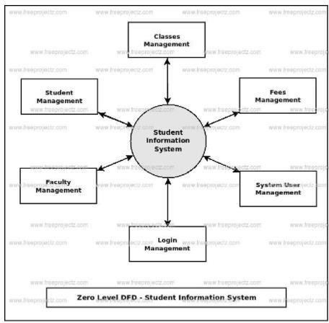

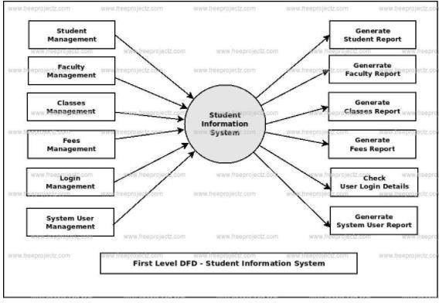

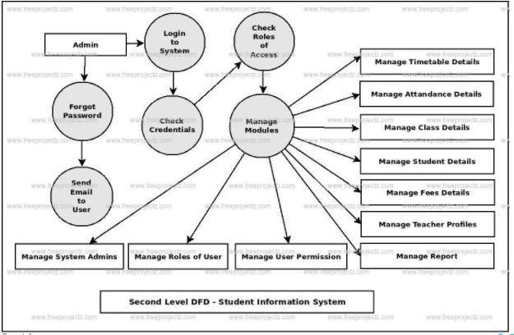

1. **CLASS DIAGRAM**

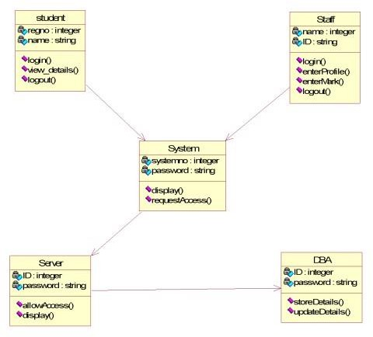

1. **COMPONENT AND DEPLOYMENT DIAGRAM**

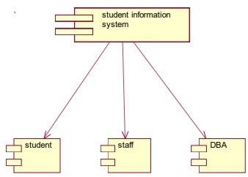

#### Component Diagram



**Deployment Diagram**

1. **USE CASE DIAGRAM**

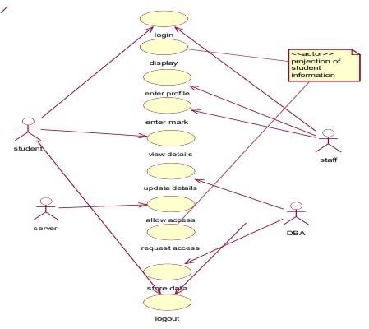

1. **SEQUENCE DIAGRAM**

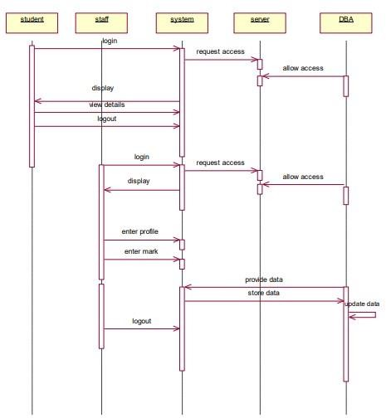

1. **COLLABORATION DIAGRAM**

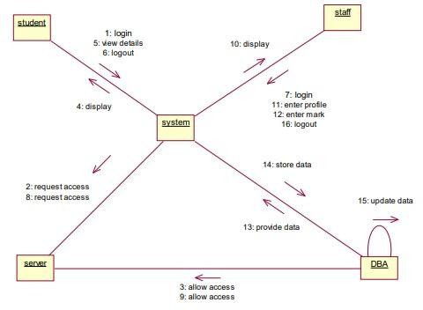

1. **ACTIVITY DIAGRAM**

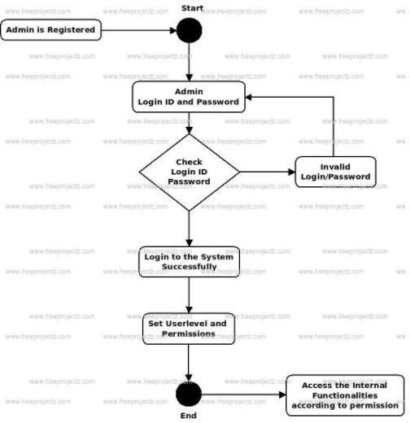

1. **STATE CHART DIAGRAM**

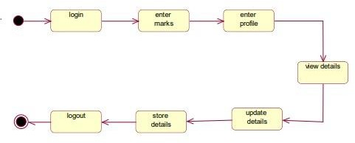

## Viva Questions And Answers

* 1. *What is state Chart Diagram?*

A Statechart diagram describes a state machine. State machine can be defined as a machine which defines different states of an object and these states are controlled by external or internal events.

* 1. *What is the Purpose of state chart Diagram?*

Statechart diagram is one of the five UML diagrams used to model the dynamic nature of a system. They define different states of an object during its lifetime and these states are changed by events. Statechart diagrams are useful to model the reactive systems. Reactive systems can be defined as a system that responds to external or internal events.

* 1. How to Draw State Chart Diagram?

Statechart diagrams are very important for describing the states. States can be identified as the condition of objects when a particular event occurs.

Before drawing a Statechart diagram we should clarify the following points −  Identify the important objects to be analyzed.

* + - Identify the states.
    - Identify the events.
  1. Where we can use State Chart Diagrams? The main usage can be described as −
     + To model the object states of a system.
     + To model the reactive system. Reactive system consists of reactive objects.
     + To identify the events responsible for state changes.
     + Forward and reverse engineering.
  2. 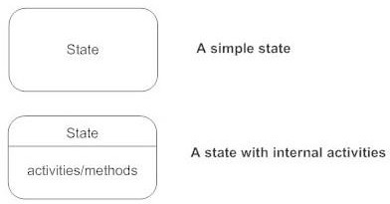Draw notation to represent a state.
  3. Write about Transition.

A solid arrow represents the path between different states of an object. Label the transition with the event that triggered it and the action that results from it. A state can have a transition that points back to itself.



* 1. Draw the notation to represent initial state and final state in state chart diagram



* 1. *What is State?*

States represent situations during the life of an object.

* 1. *What is Collaboration Diagram?*

The collaboration diagram is used to show the relationship between the objects in a system.

* 1. When to Use Collaboration Diagram?

The collaborations are used when it is essential to depict the relationship between the object.

**WEEK:8**

#### ATM

1. **Problem Statement**

ATM is another type of banking where the most frequently type of transaction made is withdrawal. A user may withdraw as much as many amount as he wants until his account holds a sum greater than his withdrawal amount.

ATM is completely automated and there is no necessity of the ATM center being placed at the bank itself. It can be placed in the shopping malls, airports, railway stations etc.

This ATM system can use any kind of interface. But it should be user friendly and not confusing. Help manuals should be provided in case any customer has problem working with the software.

## SRS Document

**1.0. INTRODUCTION**

Banking is one of the common and day to day attribute of life. Nowadays it is totally different from that existed a few years ago banking has become completely computerized new facilities such as credit cards, debit cards & ATM has been introduced. ATM is automatic teller machine which is basically used to withdraw money from an account.

* 1. **PURPOSE**

This document describes the software requirements and specification (srs) of an automated teller machine (atm). this document is intended for the customer and developer (designer, testers and maintainers). the reader is assumed to have a basic knowledge of banking accounts and accounts services. knowledge and understanding of unified modeling languages (uml) diagrams is also required.

* 1. **SCOPE**

The scope of the project is to design an ATM system that will help in completely automatic banking this software is going to be designed for withdrawal and deposit of money and register the transaction in the database where the customer’s information is stored.

* 1. **DEFINITIONS, ACRONYMS AND THE ABBREVIATIONS**

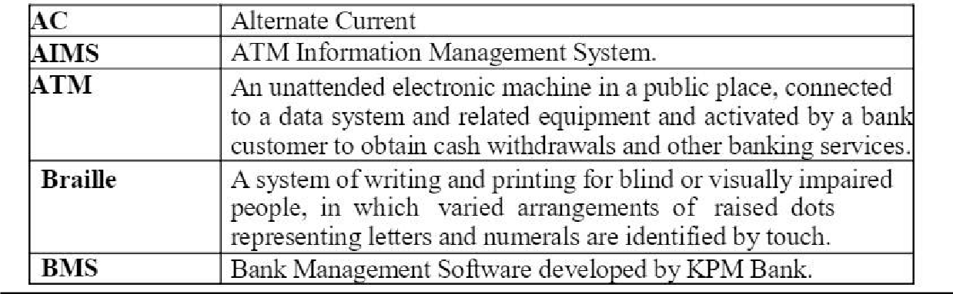

* 1. **REFERENCES**

IEEE Software Requirement Specification format.

* 1. **TECHNOLOGIES TO BE USED**
     + HTML
     + JSP
     + Javascript
     + Java
  2. **TOOLS TO BE USED**
     + Eclipse IDE (Integrated Development Environment)
     + Rational Rose tool/ STAR UML(for developing UML Patterns)
  3. **OVERVIEW**

SRS includes two sections overall description and specific requirements

**Overall Description** will describe major role of the system components and inter- connections.

**Specific Requirements** will describe roles & functions of the actors.

* 1. **OVERALL DESCRIPTION**
  2. **PRODUCT PERSPECTIVE**

The software supports a computerized banking system. The system enables customers to complete simple bank account service via an ATM. An ATM session consists of authenticating a user (i.e., proving the user's identity) based on an account number and personal identification number (PIN), followed by creating and executing financial transactions. To authenticate a user and perform transactions, the ATM must interact with the bank's account information database. For each bank account, the database stores an account number, a PIN and a balance indicating the amount of money in the account. ATM users should be able to view their account balance, withdraw cash (i.e., take money out of an account) and deposit funds (i.e., place money into an account).

### SOFTWARE INTERFACE

* + - **Front End Client** –Android Developer Tool ,Adavance Java •

**Back End** - SQL database.

### HARDWARE INTERFACE

The server is directly connected to the client systems. The client systems have access to the database in the server.

* 1. **USER CHARACTERISTICS**
     + Open to all users but access level is dependent on knowledge of the system.
     + Customers are simply members of the public with no special training.
     + Bank security personnel need have no special education or experience.
     + Maintainers must be experienced system administrators, able to upgrade and repair the system.
  2. **CONSTRAINTS**
* There will only be one administrator.
* The delete operation is available only to the administrator. To reduce the complexity of the system, there is no check on delete operation. Hence, administrator should be very careful before deletion of any record and he/she will be responsible for data consistency.

### ASSUMPTIONS AND DEPENDENCIES

* + - The login Id and password must be created by system administrator and communicated to the concerned user confidentially to avoid unauthorized access to the system.
    - It is assumed that a student registering for the subsequent semester has been promoted to that semester by the university as per rules and has paid desired university fee.

· Registration process will be open only for specific duration.

1. **Data Flow Diagrams**

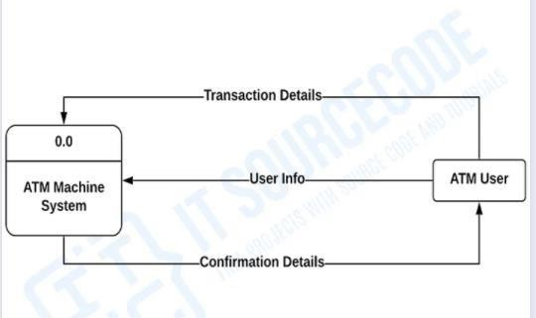

**Level ZERO DFD Diagram**

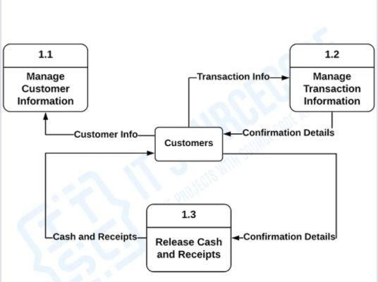

**Level ONE DFD Diagram**

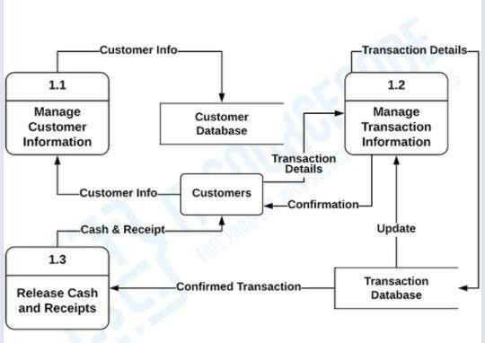

**Level Second DFD Diagram**

1. **CLASS DIAGRAM**

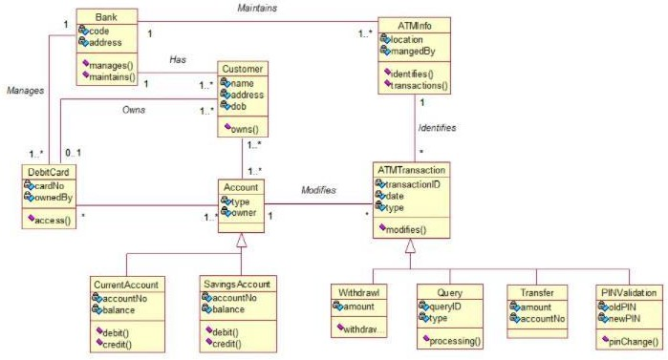

1. **COMPONENT AND DEPLOYMENT DIAGRAM**

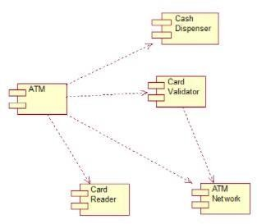

**Component Diagram**



**Deployment Diagram**

1. **USE CASE DIAGRAM**

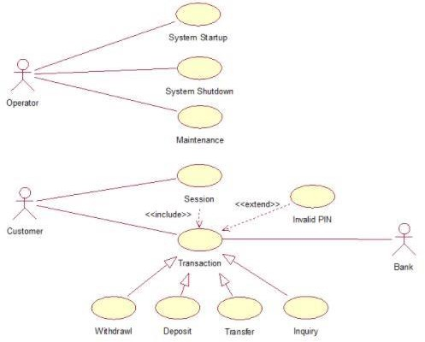

1. **SEQUENCE DIAGRAM**

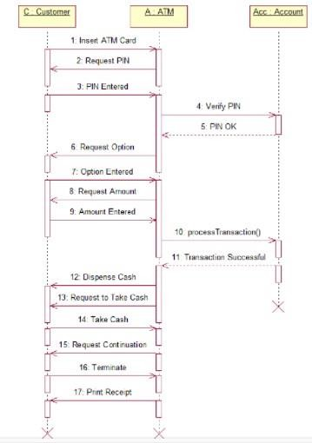

1. **COLLABORATION DIAGRAM**

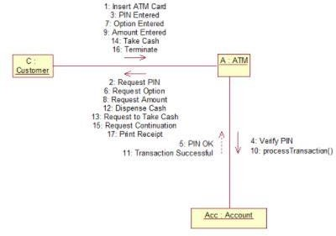

**9, ACTIVITY DIAGRAM**

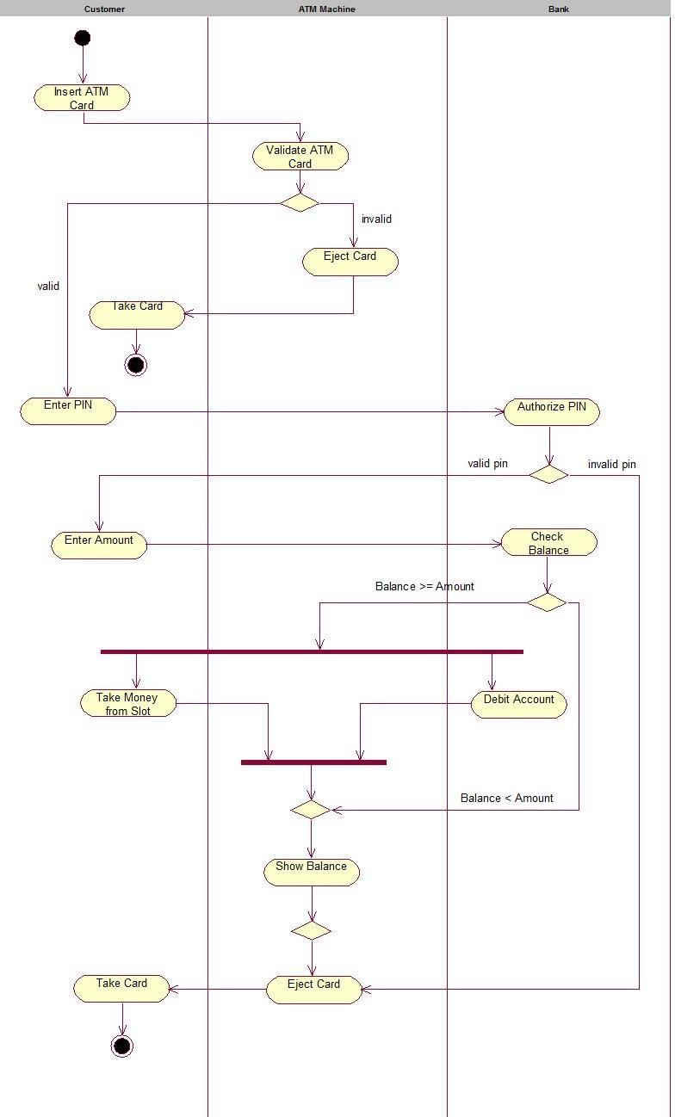

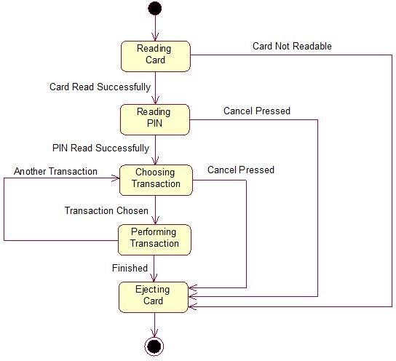

**10 STATE CHART DIAGRAM**

## Viva Questions And Answers

1. List out any four advantages of collaboration diagram.
   1. The messages transmitted over sequencing is represented by numbering each individual message.
   2. The collaboration diagram is semantically weak in comparison to the sequence diagram.
   3. The special case of a collaboration diagram is the object diagram.
   4. It focuses on the elements and not the message flow, like sequence diagrams.
2. Write any two drawbacks of Collaboration Diagram.
   1. It is a time-consuming diagram.
   2. After the program terminates, the object is destroyed.
3. List out the Notations Used Collaboration Diagram.
   1. Objects
   2. Actors
   3. Links
   4. Messages
4. List out the advantages of activity Diagram.

* Each and every activity flow in the system can be explained as it is.
* Methods, functions, and operations can be explained in detail.
* Business processes and flows can be depicted easily.
* Simplified view, though the complex system.

5). Write the disadvantage of activity diagram.

* The only drawback is the UML Activity Diagram is the messages or the communications between two components, or the user cannot be shown.

1. What are the benefits of sequence diagram?
   * Represent the details of a UML use case.
   * Model the logic of a sophisticated procedure, function, or operation.
   * See how objects and components interact with each other to complete a process.
   * Plan and understand the detailed functionality of an existing or future scenario.
2. List out the advantages of Use case diagram.
   * Use case help to capture the [functional requirements](https://reqtest.com/requirements-blog/functional-vs-non-functional-requirements/) of a system.
   * Use cases are traceable.
   * Use cases can serve as the basis for the estimating, scheduling, and validating effort.
3. . List Out the symbols Used in activity diagram.

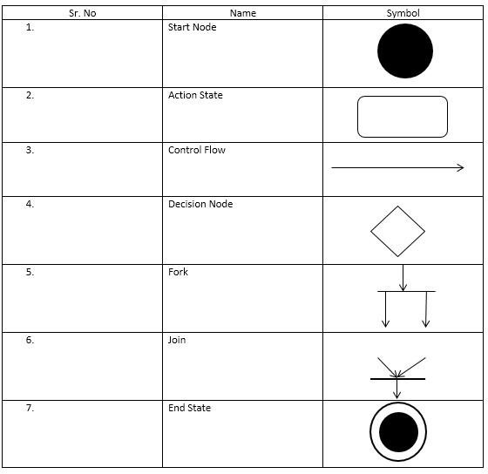

1. What is the purpose of component Diagram?

The purpose of the component diagram can be summarized as

* + Visualize the components of a system.
  + Construct executables by using forward and reverse engineering.
  + Describe the organization and relationships of the components.

1. What is the purpose of Deployment Diagram?
   * They show the structure of the run-time system
   * They capture the hardware that will be used to implement the system and the links between different items of hardware.
   * They model physical hardware elements and the communication paths between them